**CSA1086-Software Engineering**

Creating Image and Container In Docker

CSA1086 - Software Engineering

STEP 1: Open your docker in the background at all times

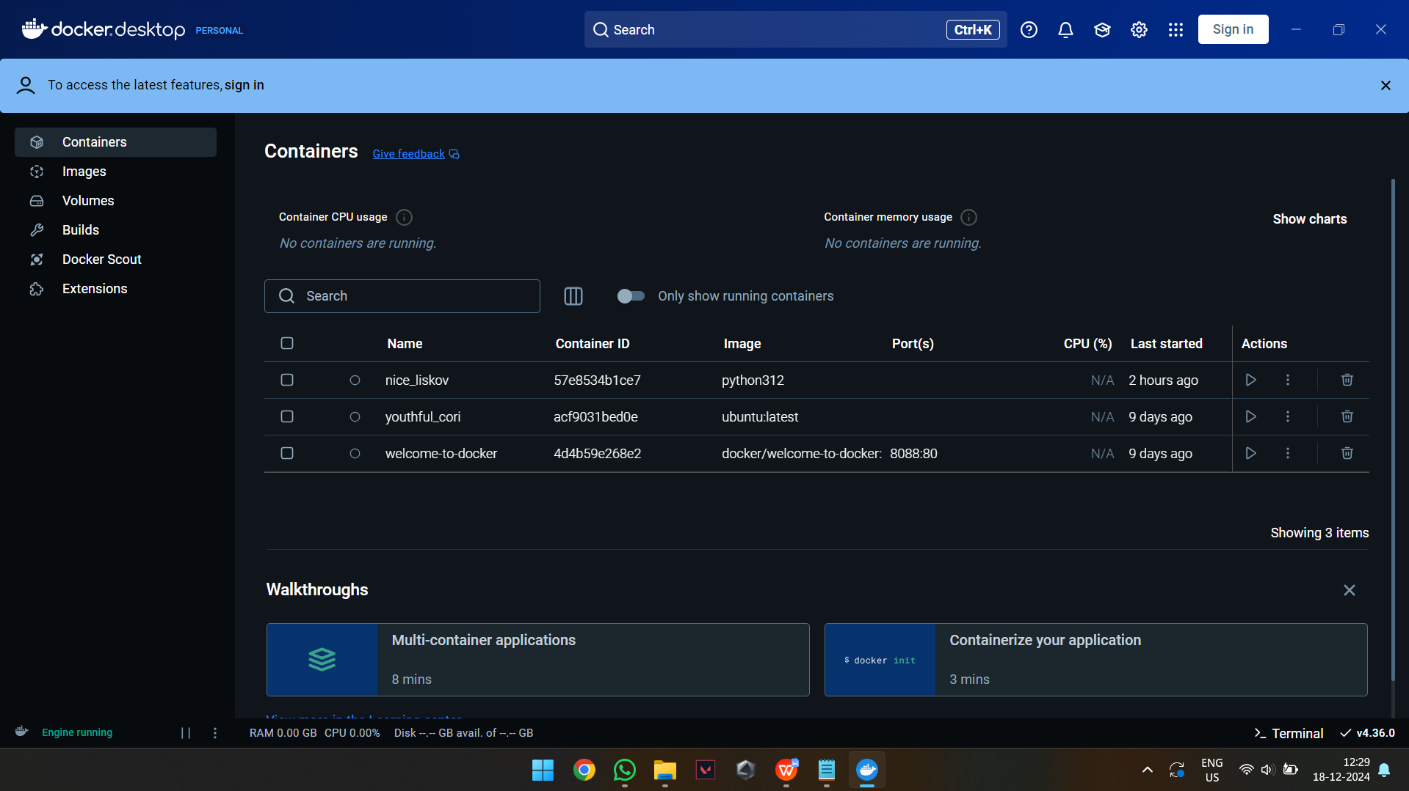

STEP 2: Create a folder named Docker and place a python file named “first.py” in the folder with some simple code

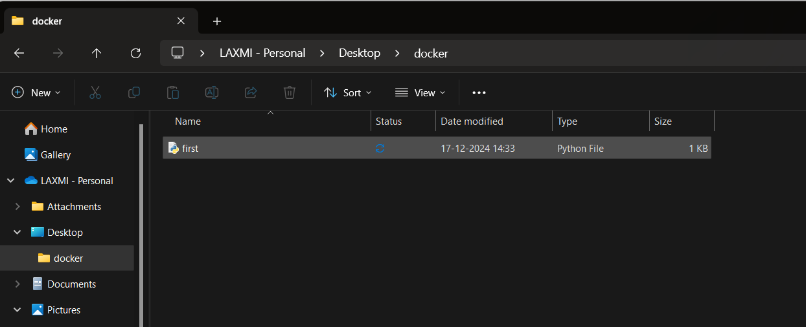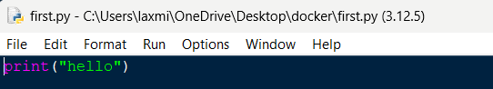

STEP 3: Create a txt file named “Dockerfile” in the Docker folder and enter the given text

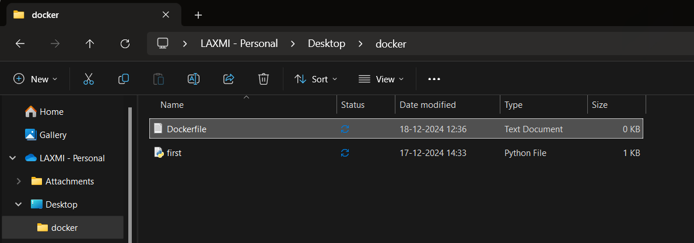

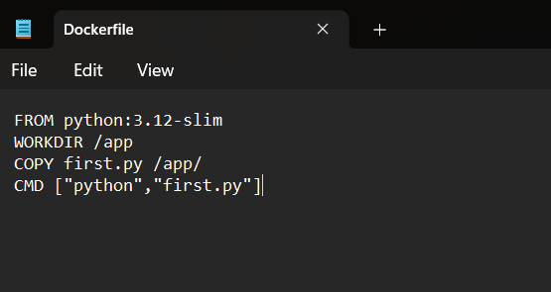

STEP 4: Open terminal in the folder and type the below code to convert txt into file

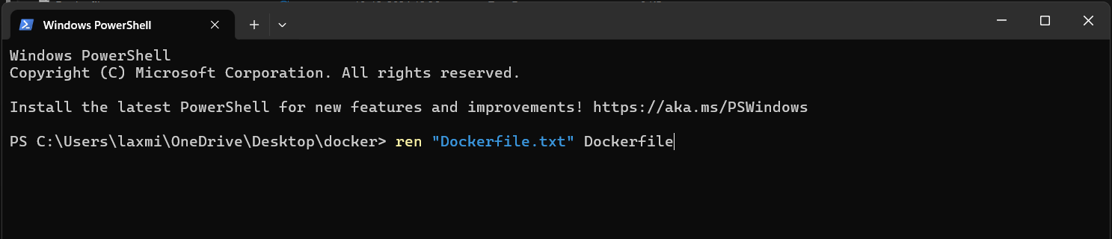

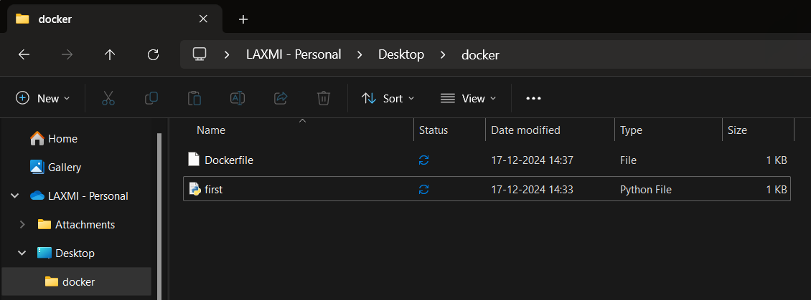

STEP 5: Type “Docker build -t python312 .” to integrate docker to terminal (312 is python version 3.12. It may vary according to your device)

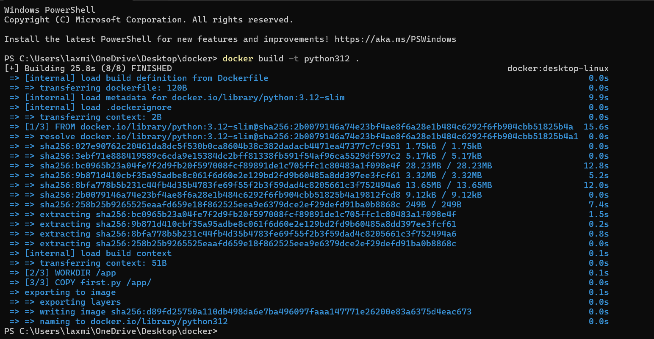

STEP 6: Type “Docker login” to login into your account

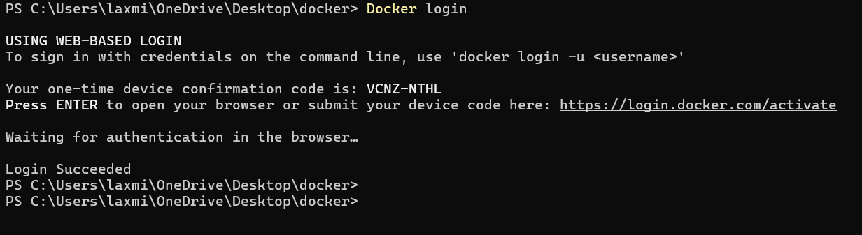

STEP 7: Type “Docker tag python312 <username>/python312” to create a container

IMG_256

STEP 8: Type “Docker push <username>/python312” to push the python file as image into the container

